School Supplies List 2023 – 2024
Mr. Schade’s Grade 6/7 Class

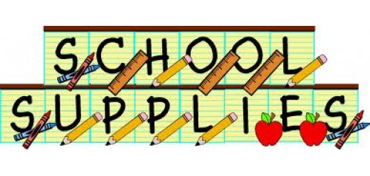
-Package of pencil crayons
-Package of markers
-10 HB pencils (dollar store not recommended)
-1 highlighter
PUT YOUR NAME ON YOUR BELONGINGS!
-A couple pens, one red and one black or blue
-1-2 glue sticks
-2-4 white erasers (they work the best)
-Calculator (depends on you…you will need more than a basic one in high school)
-1-2 black sharpies (not dollar store) I recommend that one is fine point, and one is a little thicker. We have the really fat ones here at school
-Pencil case
-2 inch binder (not the huge fabric covered 3" ones!)
-2 packages of loose-leaf lined paper
-1 Package dividers (to separate subjects in your binder)
-2 Kleenex boxes (this doesn’t seem that important…..but it is)
-1 Dry erase board (dollar store is fine)
-2 dry erase markers and some sort of eraser (anything cloth works) (dollar store is not recommended for markers)
-1 ruler (needs centimeters…..the floppy ones are NOT recommended)
1 USB stick, 4GB minimum (this is a VERY important supply)
-Set of headphones/ ear buds
-Gym strip with bag, inside non-marking court shoes are highly recommended
-1 Clipboard
-Personal hand sanitizer and sanitizing wipes
-Take home hard shell folder for homework (no more rumpled pages)

